SIMATSENGINEERING

ASSESSMENTTOOL1

NAME:V.Venkata kumar Reddy
REGNO: 192311350
COURSENAME: INTERNETPROGRAMMING
COURSECODE: CSA4308

Question 1
S u p p os e th a t a co ll e g e wa n ts to d e ve lo p an on l i n e s tu d e n t re g i s tra ti on s y s te m wh e re s tu d e n ts s u b m i t th ei r d e ta i l s thro u g h a w eb fo rm , a n d the d ata i s p ro ce s s ed u s in g a J a va S e rv l et.
Exp l a i n th e a rc h itec tu re of a s ervl e t-b a s ed ap p l i ca ti on . D es i g n a n d i m p l em en t a s e rvl et to h a n d le fo rm d a ta u s in g b oth G E T a n d PO S T m e th od s . D e s cri b e th e s e rvl et l i fe cyc le (i n i t, s e rv ic e, d es tro y) a n d j us ti fy wh i ch m e th od i s m ore a p p ro p ria te fo r h a n d l i ng s en s i ti ve d a ta .

Answer:
Servlet Architecture
A servlet-based web application follows a request/response model mediated by a servlet container (e.g. Apache Tomcat):

- Th e b rowse r se nd s a n H TTP req u est (fro m th e reg i stra tion form ) to t he we b se rve r.
- Th e se rvl et c on ta in e r rec ei ve s it, a n d — ba se d o n th e U R L p a ttern i n web . xm l or a n @W ebSe rvl et a n n ota ti on — c rea te s H ttp Se rvl etRe q u est a n d H ttpServlet Respo n se ob je cts a nd d i spa tch e s th em t o th e m a tch in g servlet in sta n ce .
- Th e se rvl et's bu sin e ss lo g ic rea d s fo rm fi eld s from th e req ue st,
pro ce sses/va l id a tes/sto res th e m , a n d w rites th e re spon se bo d y (H TM L, JSO N , or a red ire ct) .
- Th e c on ta in e r sen d s th e re spo nse ba c k to th e b rowse r, a n d ke ep s th e se rvlet in sta n ce a live in m e mo ry to serve fu tu re req u e sts (servlets a re m u lti th rea d e d si ng le ton s — o n e in sta n ce h a n d le s m a n y re q u ests con c u rren tly) .

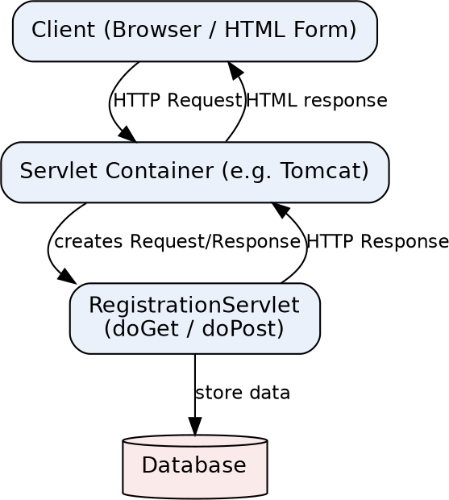

HTML Form

<form action="register" method="post">
<input type="text" name="name" placeholder="Full Name">
<input type="email" name="email" placeholder="Email">
<input type="text" name="regNo" placeholder="Registration No.">
<input type="submit" value="Register">
</form>

Servlet Implementation (handles GET and POST)

@WebServlet("/register")
public class RegistrationServletextends HttpServlet{

private Connection conn; //shared DB connection/pool handle

@Override
public void init() throws ServletException{
//Called once, when thecontainerloads theservlet.
//Ideal placetoopen a DB connection pool /read config.
try{
conn =DriverManager.getConnection(
"jdbc:mysql://localhost:3306/college", "root", "pwd");
}catch (SQLException e) {
thrownewServletException("DBinitfailed", e);
}
}

@Override
protected void doGet(HttpServletRequest req, HttpServletResponse resp) throws ServletException, IOException {
//Typicallyjustserves theemptyregistration form/page.
req.getRequestDispatcher("registerForm.jsp").forward(req, resp);
}

@Override
protected void doPost(HttpServletRequest req, HttpServletResponse resp) throws ServletException, IOException {
//Handles the actual form submission.
String name =req.getParameter("name"); String email = req.getParameter("email"); String regNo= req.getParameter("regNo");

String sql = "INSERTINTO students(name,email,reg_no) VALUES(?,?,?)";
try(PreparedStatementps = conn.prepareStatement(sql)) { ps.setString(1 , name);
ps.setString(2, email); ps.setString(3, regNo); ps.executeUpdate();
resp.sendRedirect("success.html");
}catch (SQLException e) {
thrownewServletException("Could not savestudent", e);
}
}

}

@Override
public void destroy() {
//Called once, justbefore thecontainerunloads the servlet
//(e.g. on shutdown/redeploy). Release resources here.

Servlet Life Cycle

Phase | Whenitruns | Purpose
init() | Once, thefirst time theservletis requested (oratcontainerstartup, ifload-on-startupis set) | One-time setup: open DB connections, read configuration,  allocate shared resources.
service() | Once per incoming request (dispatches internallyto  doGet/doPost/doPut/... based on theHTTP method) | Handlethe request: read parameters, run business logic, writetheresponse.
destroy() | Once, when the containerremoves theservletfrom service (shutdown, redeploy) | Cleanup: closeconnections, releaseresources, flush logs.

GET vs POST for sensitive data
POST is the appropriate method for handling sensitive registration data, and doPost() shoul d perform the actual save:
- G ET a p pen d s pa ra m ete rs to th e U R L (e. g . ?e m a il= . . .&reg N o= . . .) , so sen siti ve val u es en d u p i n bro wser hi story, se rver a c cess log s, pro xy log s, a nd c an be boo kma rke d o r sh a red a cc id e n tal ly.
- G ET re q u ests a re a l so c ac h ed by brow sers/proxie s by d e fa u lt, w hi ch ri sks sen si tive d a ta b ein g store d o u tsid e th e ap pli ca tio n's c on trol .
- U RLs h a ve pra c tica l le n g th li m its, wh i ch c an sile nt ly tru n ca te la rg e form s; PO ST h a s n o su ch restric tion sin ce d a ta tra vel s in th e req u est b od y.
- P O ST i s in te nd ed fo r sta te-c ha n g i n g o pera ti on s (crea ti n g a stu d en t re cord ) — th is a lso m a tch e s REST/H TTP sem a n tics, wh ere G ET sh o ul d b e sa fe a n d id e m pote n t
(rea d -on ly) .
GETremains appropriate onlyforthe non-sensitivestepofsimplydispl aying the emptyform.

Question 2
S u p p os e th at a we b s i te req u i re s u s ers to lo g i n a n d m ai n ta i n th e i r s es s i on a c ro s s m u lti p l e p a g e s a fte r a u th en tic a tio n .
D e s i g n a s es s i o n m a n a g em e n t s ys te m u s i n g H ttp S e s s io n a n d C o oki e s i n S e rv l ets . Exp l a i n h ow s es s i o n tra cki n g w o rks i n w eb a p p li c ati on s a n d co m p a re s es s i on -b a s ed tra c ki n g wi th co oki es .

Answer:

How session tracking works
HTTP is stateless — each request is independent, so the server has no built-in memory of a previous request from the same user. Session tracking solves this by attaching a unique identifier to the user's browser, which is sent back on every subsequent request so the server can look up that user's stored state:
- O n first c on ta ct, the c on ta in er cre ate s a n H ttpSessi on ob je ct a nd a u n iq ue se ssion I D .
- Th e se ssion ID is se n t to t he bro wse r a s a c ooki e n a m ed J SESSI O N ID (or a ppe n d ed to
U RLs via U RL rew ritin g if co okie s a re d isa bl ed ) .
- O n e ve ry la te r req u est, th e bro wser a ut om a tica l ly re sen d s th at co okie ; th e co n tai n er
u ses it to fe tch th e m a tch in g H ttp Sessio n obje ct a n d its sto red a ttribu te s.
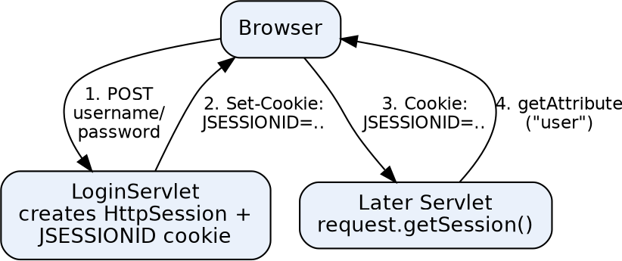

Login Servlet – creating a session

@WebServlet("/login")
public class LoginServletextends HttpServlet{
protected void doPost(HttpServletRequest req, HttpServletResponse resp) throws ServletException, IOException {
String user= req.getParameter("username");
String pass = req.getParameter("password");

if(AuthService.isValid(user, pass)) {
HttpSessionsession= req.getSession(true); //create ifabsent session.setAttribute("username", user);
session.setMaxInactiveInterval(30 *60); //30 minutes
resp.sendRedirect("dashboard");
}else {
resp.sendRedirect("login.html?error=1 ");
}
}
}

Any Later Page – reading the session

@WebServlet("/dashboard")
public class DashboardServlet extends HttpServlet{
protected void doGet(HttpServletRequest req, HttpServletResponse resp) throws ServletException, IOException {
HttpSession session = req.getSession(false); //don'tcreatea newone if(session== null || session.getAttribute("username") == null) {
resp.sendRedirect("login.html"); //notauthenticated
return;
}
String user= (String) session.getAttribute("username");
req.setAttribute("user", user);
req.getRequestDispatcher("dashboard.jsp").forward(req, resp);
}
}

Logout – invalidating the session

@WebServlet("/logout")
public class LogoutServletextends HttpServlet {
protected void doGet(HttpServletRequest req, HttpServletResponse resp) throws ServletException, IOException {
HttpSession session = req.getSession(false);
if(session!=null) session.invalidate();
resp.sendRedirect("login.html");
}
}

Equivalent design using plain Cookies
Instead ofrelying on thecontainer's HttpSession, the application could manage a token itself:

//Aftersuccessful login:
CookieauthCookie = newCookie("authToken", token); authCookie.setHttpOnly(true); //notaccessible to JavaScript authCookie.setSecure(true); //onlysentoverHTTPS authCookie.setMaxAge(30 *60); //30 minutes
resp.addCookie(authCookie);

//On a laterrequest:
Cookie[] cookies = req.getCookies();
String token = Arrays.stream(cookies)
.filter(c->c.getName().equals("authToken"))
.map(Cookie::getValue).findFirst().orElse(null);
//token is then looked upin a server-side store(DB/cache) tofind theuser

Any Later Page – reading the session

@WebServlet("/dashboard")
public class DashboardServlet extends HttpServlet{
protected void doGet(HttpServletRequest req, HttpServletResponse resp) throws ServletException, IOException {
HttpSession session = req.getSession(false); //don'tcreatea newone if(session== null || session.getAttribute("username") == null) {
resp.sendRedirect("login.html"); //notauthenticated
return;
}
String user= (String) session.getAttribute("username");
req.setAttribute("user", user);
req.getRequestDispatcher("dashboard.jsp").forward(req, resp);
}
}

Logout – invalidating the session

@WebServlet("/logout")
public class LogoutServletextends HttpServlet {
protected void doGet(HttpServletRequest req, HttpServletResponse resp) throws ServletException, IOException {
HttpSession session = req.getSession(false);
if(session!=null) session.invalidate();
resp.sendRedirect("login.html");
}
}

Equivalent design using plain Cookies
Instead ofrelying on thecontainer's HttpSession, the application could manage a token itself:

//Aftersuccessful login:
CookieauthCookie = newCookie("authToken", token); authCookie.setHttpOnly(true); //notaccessible to JavaScript authCookie.setSecure(true); //onlysentoverHTTPS authCookie.setMaxAge(30 *60); //30 minutes
resp.addCookie(authCookie);

//On a laterrequest:
Cookie[] cookies = req.getCookies();
String token = Arrays.stream(cookies)
.filter(c->c.getName().equals("authToken"))
.map(Cookie::getValue).findFirst().orElse(null);
//token is then looked upin a server-side store(DB/cache) tofind theuser

HttpSession vs. Cookies

Aspect | HttpSession | Cookies
Where data lives | On theserver; onlyanID is sentto  the client | Entirelyon the client(browser)
Data types | AnyJava object  (setAttribute(String, Object)) | Textonly(name=value strings)
Size limit | Effectivelybounded by server memory | ~4 KBpercookie, limited cookies perdomain
Security | Safer— sensitive data never leaves theserver | Riskierifitholds sensitive data  directly; needs HttpOnly/Secure flags
Dependency | Still needs a cookie(JSESSIONID)  orURL rewriting tocarrythe  session ID | Is itselfthe storage/transport mechanism
Lifetime control | Server-sidetimeout  (setMaxInactiveInterval ) or invalidate() | Client-sideexpiry(setMaxAge);  usercan alsodelete manually
Scal ability | Needs stickysessions or a shared  sessionstore across servers | Naturallystateless server-side —  easiertoscale horizontally

In practice, HttpSession is generally preferred for authentication state because sensitive data stays server-side, while cookies remain essential as the transport that carries the session identifier itself — the twotechniques worktogetherratherthan being fullyalternativechoices.

Question 3
S u p p os e th a t a n e-com m erce p l a tform n ee d s to s to re a n d re tri ev e p ro d u c t d e ta i l s
from a d a ta b a s e u s i n g a J a va -b a s ed w e b a p p li c a ti o n.
D e s i g n a J D B C -b a s ed a p p l ic a tio n to c on n e ct to a d a ta b a s e , in s e rt p rod u c t d a ta , a nd retrie ve i t u s in g S Q L q u e ri e s . E xp l a in th e J D B C a rch i tec tu re a n d d es cri b e th e s tep s i n vo lv ed in d a ta b a s e co n n ec ti v ity a l on g w i th p ro p e r exce p ti on h a n d l i n g .

Answer:

JDBC Architecture
JDBC (Java Database Connectivity) is a standard Java API that lets an application talk to a relational databaseindependent ofwhich vendor's database is used:
- J D B C AP I — th e ja va .sq l / ja va x. sq l in terfa ce s (C on n ect ion , Sta tem e n t, Re sul tSet, e tc. )
th a t a pp lic a tion c od e pro g ra m s a g a i nst .
- D riverM a n a g e r — l oca te s a n d l oa d s t he c orrec t J D B C d ri ve r for a g iven c on n ec tion
U RL.

- J D B C D river — a ven d o r-sp ec ifi c i m ple m en ta tion (typ ica ll y a 'Type 4' pu re-J a va d river, e. g . M ySQ L Con n e ctor/J ) th a t tra n sla tes J D BC ca ll s in to th e d at ab a se's n a tive n e twork pro toco l.
- D a ta ba se — th e a ctu a l R D BM S (M ySQ L, P ostg reSQ L, O ra c le, etc .) th a t e xe cu tes th e SQ L a n d retu rn s re su lts.
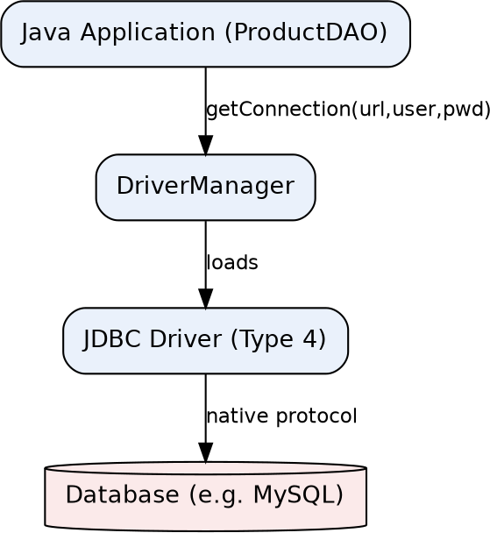

Steps involved in database connectivity
- 1 . Loa d /re g iste r th e d river (m od ern J D B C 4 + d ri ve rs a u to-reg ister vi a M ETA-I N F/service s, so th is is u sua l ly i mp lic it) .
- 2. O p en a c on n ec tion with D ri ve rM a na g er. g e tCon n ec tion (u rl, u ser, pa sswo rd ).
- 3 . Cre a te a Sta te m en t o r (prefera bl y) a Pre pa re d Sta tem en t to a void SQ L i n je cti on a n d be n efit from q ue ry p la n ca c h in g .
- 4. E xe cu te th e q u ery: exec ut eU pd a te() for I N SE RT/U P D ATE/D E LETE, execu te Q u ery() fo r SELECT (retu rn s a R esu ltSet) .
- 5. P roc ess t he Re su ltSet b y it era tin g with rs. n e xt() a n d rea d i n g c olu m n s.
- 6. Cl ose a ll re sou rc es (Resu l tSe t, Sta tem e n t, Con n ec tion ) — i d ea l ly w ith
try-wit h-re sou rce s, so the y c lose a u tom a tic a lly even if a n e xc ept ion o ccu rs.

ProductDAO – insert and retrieve


public class ProductDAO{
private staticfinal String URL=
"jdbc:mysql://localhost:3306/shopdb?useSSL=false&serverTimezone=UTC";
private staticfinal String USER= "root";
private staticfinal String PASS= "password";

//----INSERT----
public void addProduct(String name, double price, intqty) {
String sql = "INSERTINTO products(name, price, qty) VALUES(?, ?, ?)";
try(Connectionconn = DriverManager.getConnection(URL, USER, PASS);
PreparedStatementps = conn.prepareStatement(sql)) {

ps.setString(1 , name); ps.setDouble(2, price); ps.setInt(3, qty);
introws = ps.executeUpdate();
System.out.println(rows +" row(s) inserted.");

}catch (SQLException e) {
System.err.println("Insertfailed: " +e.getMessage());
//Ina real app: log via a logging frameworkand/or
//rethrowas a customDataAccessException.
}
}

//----RETRIEVE ----
public List<Product>getAllProducts() { List<Product> list= newArrayList<>();
String sql = "SELECTid, name, price, qtyFROMproducts";

try(Connectionconn = DriverManager.getConnection(URL, USER, PASS);
PreparedStatementps = conn.prepareStatement(sql);
ResultSetrs = ps.executeQuery()) {

while(rs.next()) {
list.add(newProduct( rs.getInt("id"),
rs.getString("name"),
rs.getDouble("price"), rs.getInt("qty")));
}

}catch (SQLException e) {
System.err.println("Queryfailed: " + e.getMessage());
}
return list;
}
}

Exception handling notes
- try-wit h-re sou rce s (u se d a b ove ) g u a ra n tees Con n ec tion , Pre pa red Sta te m en t, a n d Re su ltSet a re cl osed in reverse ord e r a u tom a tic a lly, even i f
exec u teU p d a te()/e xe cu teQ u e ry() th row s — a void i n g l ea ked D B co n ne cti on s.
- SQ LExce pti on ca rri es a ve nd or e rror cod e a n d SQLSta te; ca tc h it sp ec ifi ca lly ra th er th a n a g e n eri c E xc epti on , a n d l og e. g e tM essa g e () (a n d e. g e tSQ LStat e() if u se fu l)
in ste a d of e xp osin g ra w D B e rrors to en d u sers.
- P repa re d Sta tem e n t with '?' pl a ceh o ld e rs (ra th e r th a n strin g -c on ca te n at ed SQ L)
pre ve n ts SQ L i n je cti on , wh i ch m a tters d ire ctl y fo r a p ub lic -fa ci ng e -c om m erc e form .
- For mu l ti-step ope ra tion s (e. g . d ed uc t sto ck a n d rec ord an ord e r tog eth er), w rap th em in a tra nsa c tion : co nn . se tAu toCom m it(fa l se), th en c on n .c om m it() on su cc ess or
co n n .ro llba c k() in a ca tch blo ck.

RUBRICSFORCALCULATION:

Criteria | Weightage(%) | Level 4  (Exemplary) | Level 3  (Proficient) | Level 2  (Developing) | Level 1  (Beginning)
 |  | Demonstrates
Understanding  ofScenario | 20% | clearand  complete understanding ofthe scenario | Shows good understanding with minorgaps | Partial  understanding; misses key aspects | Misinterprets or  failsto understand the scenario
 |  | and context
Identification of KeyIssues | 20% | Accurately  identifiesall relevant issues  and factors  involved | Identifies most keyissues with minor  omissions | Identifies  limited issues; some irrelevant points | Unable to  identifykey issues
 |  | Applies
Application of Concepts | 25% | appropriate  concepts effectivelyto address the | Applies concepts with minorerrors | Limited or partiallycorrect application | Unable toapply relevant concepts
 |  | scenario
 |  | Makes | Makes | Makesweak decisions with limited  justification | No clear decisionsmade  orrationale provided
 |  | well-reasoned, | reasonable
Decision Making | 20% | logical | decisionswith
 |  | decisions with | some
 |  | strong rationale | justification
Clarityof  Response | 1 5% | Response is  clear, structured, and logically presented | Generallyclear with minor  issues | Somewhat  unclearorpoorly structured | Disorganized and difficult to understand

